CERTIFICATE
To Whom So Ever It May Concern

It is to certify that this project is the bonafide work of Shivam Agrawal , class 12-C of Sunbeam English School, Bhagwanpur, Lanka, Varanasi. He has developed this Java project under my supervision, following strictly the guidelines of CBSE through the academic session 2017-2018.

Mr. Vinay Kumar Srivastava
(PGT-Computer Sc.)
Kaun Banega Crorepati

CONTENTS

- Preface

- Acknowledgement

- Introduction of Java & MySQL

- Project Introduction

- Database Files Used

- Program Code

- Form Layouts

- Sample Output Reports

PREFACE

Today’s age is the age of computers. Computers have become the essential part of our life as they automate our task in easy & convenient way. That’s why computers are used everywhere.
Hence I’ve also put my efforts by creating a computerized project on “Kaun Banega Crorepati (Quiz Game)”.
The decisions made before making a project are:-
- Goals & objectives of the proposed system.
- Output that to be produced.
- Input to be used.
- Type of interface to be provided.

The Front End used in this application is “ Java Netbeans IDE 7.4” as it is responsible for receiving user’s queries, requests, & passing it to the Back End. It has the following features:-
- Java is portable, robust, platform independent and object oriented.
- It supports event driven programming.
- It supports use of RAD tools (drag and drop feature).
The back end used in this application is MySQL as it is Relational Database management System & very large no. of facilities for security, fast processing, removing inconsistency.

ACKNOWLEDGEMENT

I hereby take this opportunity to express my sincere gratitude & thankfulness to all the people who have made vital contribution in the execution & completion of this project work.
This project on “Kaun Banega Crorepati (Quiz Game)” is the outcome of diligence & guidance of our informatics PGT “Mr.Vinay Kumar Srivastava”, whose immense knowledge on this subject has proved to be the key to success on this project.
I’m also thankful to Mr. Pradumna Singh, Mr. Dhananjay Singh, Mr. Krishna Bhagwan Mishra and Mr. Kaushal Srivastava whose cooperation encouraged me to put my efforts toward completion of this project work.
I would also like to thank Lab attendant Mr. Abhijeet Dey and Lab boy Mr. Ghanshyam for their constant help and support.

Shivam Agrawal
12 C

Java: An Introduction
Java is a general purpose, high-level programming language developed by Sun Microsystems. A small team of engineers, known as the Green Team, initiated the language in 1991. Java was originally called OAK, and was designed for handheld devices and set-top boxes. Oak was unsuccessful, so in 1995 Sun changed the name to Java and modified the language to take advantage of the burgeoning World Wide Web.
Later, in 2009, Oracle Corporation acquired Sun Microsystems and took ownership of two key Sun software assets: Java and Solaris.(Operating System)

Java Today
Today Java is a commonly used foundation for developing and delivering content on the Web. According to Oracle, there are more than 9 million Java developers worldwide and more than 3 billion mobile phones run Java.

An Object-Oriented Language
Java is an object-oriented language similar to C++, but simplified to eliminate language features that cause common programming errors. Java source code files (files with a .java extension) are compiled into a format called bytecode (files with a .class extension), which can then be executed by a Java interpreter. Compiled Java code can run on most computers because Java interpreters and runtime environments, known as Java Virtual Machines (VMs), exist for most operating systems, including UNIX, the Macintosh OS, and Windows. Bytecode can also be converted directly into machine language instructions by a just-in-time compiler (JIT). In 2007, most Java technologies were released under the GNU General Public License.

Java on the Web
Java is a general purpose programming language with a number of features that make the language well suited for use on the World Wide Web. Small Java applications are called Java applets and can be downloaded from aWeb server and run on your computer by a Java-compatible Web browser.
Applications and websites using Java will not work unless Java is installed on your device. When you download Java, the software contains the Java Runtime Environment (JRE) which is needed to run in a Web browser. A component of the JRE, the Java Plug-in software allows Java applets to run inside various browsers.

Free Java Download
The official Java website provides links to freely download the latest version of Java. You can use the Java website to learn more about downloading Java, verify Java is installed on your computer, remove older versions, troubleshoot Java or report an issue. After installing Java, you will need to restart your Web browser.

MySQL: An Introduction

MySQL is an open source relational database management system (RDBMS) based on Structured Query Language (SQL).
MySQL, which was originally conceived by the Swedish company MySQL AB, was acquired byOracle in 2008. Developers can still use MySQL under the GNU General Public License (GPL), but enterprises must obtain a commercial license from Oracle.
MySQL runs on virtually all platforms, including Linux, UNIX, and Windows. Although it can be used in a wide range of applications, MySQL is most often associated with web-based applications and online publishing and is an important component of an open source enterprise stack called LAMP. LAMP is a Web development platform that usesLinux as the operating system, Apache as the Web server, MySQL as the relational database management system and PHP as the object-oriented scripting language. (Sometimes Perl or Python is used instead of PHP.)

DIGITAL INDIA PROGRAMME
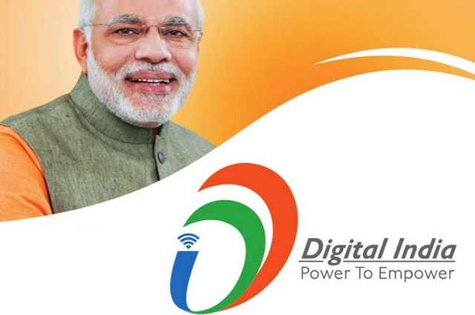Digital India is an initiative of Government of India to integrate the government departments and the people of India. It aims at ensuring that the government services are made available to citizens electronically by reducing paperwork. The initiative also includes plan to connectrural areas with high-speed internet networks.

The creation of digital infrastructure
1. A programme to transform India into digital empowered society and knowledge economy.
2. The vision of Digital India aims to transform the country into a digitally empowered society and knowledge economy.
3. The programme will be implemented in phases from the current year till 2018

A two-way platform will be created where both the servicproviders and the consumers stand to benefit. The scheme will be monitored and controlled by the Digital India Advisory group which will be chaired by the Ministry of Communications and IT. It will be an inter-ministerial initiativewhere all ministries and shall offer their own services to the public Healthcare, Education, Judicial services etc. The Public-Private-Partnership model shall be adopted selectively. In addition, there are plans to restructure the National Informatics Centre. This project is one among the top priority projects of the Modi Administration.

Several events were held across 36 states and union territories, covering 600 districts in the country.

Information Technology companies were told to organise a mandatory viewing of the speech to be delivered by PM Narendra Modi at the launch of the Digital India Initiative.

What is Digital India?
With the launch of Digital India programme, the government is taking a big step forward to transform the country into a digitally
empowered knowledge economy.

Scope of Digital India
1. To prepare India for a knowledge future.
2. On being transformative that is to realize IT (Indian Talent) + IT (Information Technology) = IT(India Tomorrow).
3. Making technology central to enabling change.
4. On being an Umbrella Programme –covering many departments.
The programme includes projects that aim to ensure that government services are available to citizens electronically and people get benefit of the latest information and communication
technology.

Apps for Digital India
Digital India Portal, MyGov Mobile App, Swachh Bharat Mission App and Aadhaar Mobile Update App

Vision of Digital India
Digital Infrastructure as a Utility to Every Citizen-Governance & Services on Demand Digital Empowerment of Citizens

Pillars Of Digital India
1. Broadband Highways
2. Universal Access to Phones
3. Public Internet Access Programme
4. e-Governance – Reforming government
through Technology
5. e-Kranti – Electronic delivery of services
6. Information for All
7. Electronics Manufacturing – Target NET
ZERO Imports
8. IT for Jobs
9. Early Harvest Programmes

Impact of Digital India by 2019
- Broadband in 2.5 lakh villages, universal phone connectivity
- Net Zero Imports by 2020
- 400,000 Public Internet Access Points
- Wi-fi in 2.5 lakh schools, all universities; Public wi-fi hotspots for citizens
Digital Inclusion: 1.7 Cr trained for IT, Telecom and Electronics Jobs

Job creation: Direct 1.7 Cr. and Indirect at least 8.5 Cr

e-Governance & e-Services: Across government India to be leader in IT use in services – health, education, banking

Digitally empowered citizens – public cloud, internet access

Benefits of Digital Locker
Digital Locker facility will help citizens to digitally store their important documents like PAN card, passport, mark sheets and degree certificates.

Digital Locker will provide secure access to Government issued documents. It uses authenticity services provided by Aadhaar. It is aimed at eliminating the use of physical documents and enables sharing of verified electronic documents across Govt Agencies.

Digital Locker provides a dedicated personal storage space in the cloud to citizens, linked to citizens Aadhaar number.
Digital Locker will reduce the administrative overhead of government departments and agencies created due to paper work.
It will also make it easy for the residents to receive services by saving time and effort as their documents will now be available anytime, anywhere and can be shared electronically.

To sign-up for your Digital Locker, one need your Aadhaar number and a Mobile number that is linked to that Aadhaar Number.

What is National Optical Fibre Network (NOFN)?
NOFN proposes seven lakh kilometers of optical fibre to be laid to connect 250 gram panchayats in three years. Public Wi-fi spots will be provided around the clusters after that and all villages will be provided with internet connectivity.
According to Communications and Information Technology Minister Ravi Shankar Prasad, “ten states including Maharashtra, Madhya Prasad, Rajasthan, West Bengal, Haryana and Chhattisgarh, are ready to roll out the NOFN to facilitate Digital India. States like Telangana, Meghalaya, Jharkhand have decided to observe Digital India Week (DIW) from July 1 to July 7.
The University Grants Commission (UGC) also directed all varsities and higher education institutes across the country to observe the Digital India Week.

Benefits of Digital India
1. It would bring in public accountability through mandated delivery of government’s services electronically.
2. It will be done through a Unique ID and e-Pramaan based on authentic and standard based interoperable and integrated government applications and data basis.

The Government of India has initiated a giant leap forward to transform the country into a digitally empowered knowledge economy. DI will help in leveraging India’s Globally acclaimed IT competence for the benefit of 120 Crore Indians.
It will help in reducing corruption, getting things done quickly and will help in reducing paper work.
Some of the facilities which would be available through this initiative are Digital Locker,e-education, e-health, Digital Signature and national scholarship portal.

Digital India: Challenges and opportunities
I would suggest the govt make 2015-16 the year of broadband highways and ensure at least 50,000 panchayats are truly connected and functional
We are in the middle of Digital India Week. Prime Minister Narendra Modi opened the week on 1 July with a kind of a function we have never seen before. The function at the Indira Gandhi indoor stadium was no less vibrant than corporate product launches. It had all the glitz of money, multimedia, videos, tall promises and, as a token, two women brought from villages to be handed over a laptop each in recognition of how they were using the Internet and computers to be successful entrepreneurs.
I also observed that the people invited to the event were the 1%—those who were connected, successful and do not need the help of any of those nine pillars on which Digital India is structured. All those living far away in inaccessible areas in rural India who need to be connected were nowhere to be seen. The event merely mentioned that 40-odd panchayats were connected through video conferencing using the national optic fibre network (NOFN).Corporate announcements made at the event in the name of Digital India were not new investments, but existing plans which were now aligned to the programme. I would have appreciated if one of them had said that they would connect a certain percentage of India’s 250,000 panchayats, or that they would providedigital literacy to a large number of villagers, or that they would adopt villages to make them broadband-connected

It is on record that not a single telecom operator or industry house has signed up to partner the NOFN programme, despite the department of telecom inviting them several times.

I have always liked the Digital India programme for one reason: It was hyped up so much that many businesses who had never thought of digital inclusion were now talking about it and, in many cases, deploying their charity spending on digital literacy or women’s empowerment through digital tools or mobile phones.

Yet, when I sat through the entire course of the celebratory Digital India Week opening, two thoughts went through my mind.

One, why are we calling it a Digital India programme? It actually should have been called a Digital Bharat programme, considering
the challenges to connect the majority of the masses of India. We usually relate Bharat with our rural folk. Since the majority of the
population live in rural areas often called Bharat, we actually needa Digital Bharat programme to ensure that Bharat is as connected and digital as India, which lives in its metros and cities.Two, why are we calling it a Digital India Week?
Because to realize Digital India, and if we are serious about making the whole country digitally enabled, we need a Digital India decade, or even to create and keep the momentum sustainable and action oriented, we need at least a Digital India Year.

A Digital India Year would make sure that each and every aspect of the programme is pushed to show results on the ground and not go into hibernation after one week of enthusiasm.

Considering that most of the nine pillars of the Digital India programme face serious challenges in implementation, it is imperative that focused, persistent attention be given to each
of its pillars so that the big programme does not end up in embarrassment and failure.

Considering that the Digital Empowerment Foundation has a footprint at more than 150 locations in India at the village level, and that too with the purpose of digitally enabling the poorest of the poor, let me highlight some of the major challenges of the Digital India programme.

First and foremost is that the entire programmeis designed as a top-down model. There is no idea of how it would be implemented on the ground to be successful. For example, let’s consider six of the nine pillars of the programme directly related to consumers and people at large: broadband highways, universal access to mobile connectivity, public Internet access programme, e-kranti or electronic delivery of services, information for all, and IT for jobs.

Broadband highways, now called BharatNet, is supposed to connect up to gram panchayat, but laying fiber optic cables is the least of the challenges here. The biggest challenge is ensuring that each panchayat point of broadband is fired up, functional, used and distributed. Our research work found that more than 67% of the NOFN points are nonfunctional, even at the pilot stage. Besides, if the broadband highways programme is not implemented well and soon, we may not be able to implement other pillars of the able to implement other pillars of theprogramme, such as the public Internet access programme, e-kranti, information for all, and even IT for jobs. All these are dependent on access infrastructure.

Out of the many initiatives launched during the Digital India week, one that could make a serious impact is BSNL’s (Bharat Sanchar Nigam Ltd) mass deployment of Wi-Fi hotspots across the country. If the government pushes BSNL to ensure at least one hotspot per panchayat or per village, it can do wonders, and the government can also show off this as a positive outcome. However, if the selection of the locations for the hotspots necessarily were
those populated by mostly tribals, backward castes, minorities and geographically difficult areas, then the impact would be something that would be a national story.

INTRODUCTION

Kaun Banega Crorepati (Who Will Become a Millionaire; also simply known as KBC) is an Indian television game show based on the British program Who Wants to Be a Millionaire? It originally aired on Star Plus for the first 3 seasons from 2000 till 2007 and was commissioned by the programming team of Sameer Nair. Since 2010, it has been airing on Sony TV and produced by Big Synergy.

Director Danny Boyle's 2008 film Slumdog Millionaire was loosely based on the show. The movie's host, based loosely on the actual host Amitabh Bachchan, was portrayed by Anil Kapoor. Kapoor himself has appeared on a celebrity version of the show.

Broadcast details

Season 1: 2000–01
KBC premiered on 3 July 2000 and was hosted by Amitabh Bachchan, his first appearance on Indian television. KBC initially offered contestants the chance to win 1 Crore Indian rupees. The season ended in 2001. The show was well received in its premiere season.

Season 2: 2005–06
On 5 August 2005, the show was restarted after a four-year hiatus, and renamed Kaun Banega Crorepati Dwitiya or KBC 2. During this season, the top prize amount was doubled to 2 Crore Rupees. It was abruptly ended by STAR Plus after Amitabh Bachchan fell ill in 2006.Mr Bachchan had shot 61 of the 85 scheduled episodes when he fell ill. He announced he would return after he recovered, but when his health prevented him filming the remaining 24 episodes, Star TV took the decision to axe it.

Season 3: 2007
Star Television recruited Shahrukh Khan to host the third season of the show. The grand prize remained 2 Crore Rupees. The third season of the show began airing on 22 January 2007. However, the show's ratings dropped significantly due to the change in hosts. The season ended on 19 April 2007 with a special finale.

Season 4: 2010
The fourth season (called KBC 4) was hosted by the returning Amitabh Bachchan and started on 11 October 2010, on Bachchan's 68th birthday. This season was telecast four days a week, Monday through Thursday evenings. The tagline of the season was "Koi Bhi Sawaal Chota Nahi Hota" (English: No question is small. Literally: Every question is important). The show moved from STAR Plus to Sony TV. The new logo designed for the fourth season incorporated the new Indian Rupee symbol, which was unveiled earlier in the year. The contestant tryout for the fourth season opened on 2 August 2010 at 9 PM IST. The total prize money for this season was 1 Crore, and a jackpot question for 5 Crore. The fourth season of the show was highly successful due to the return of former host Amitabh Bachhan. The season ended on 9 December 2010.

During this season, much like it's international counterparts, there were various rules changes made to the show. The number of questions were reduced from 15 to 13 and similar to the United States, a clock was added to each question. There was a 30-second time limit for questions 1 and 2, and a 45-second time limit for questions 3 to 7. Questions 8 to 13 were not timed. Any time not used was voided and not banked (unlike the United States version which banked the time for the final question). Much like other countries' version of the game, the clock stops whenever a lifeline is used and if the time limit expired, the contestant was forced to walk away with their current winnings. This season introduced the "Double Dip" and "Ask the Expert" lifelines (similar to the United States counterpart from the Millionaire clock format).

Season 5: 2011
Amitabh Bachchan returned to host the fifth season which premiered on 15 August 2011 on the Independence Day of India and ended on 17 November 2011. It was again aired four days a week. Compared to the previous season, there was only one major gameplay change: there was only a single milestone (the Padao) that the contestant chose. The tagline used for the season was "Koi Bhi Insaan Chota Nahi Hota" (English: No human is small). This season was the generally viewed as the most popular show on Indian television in 2011. This season introduced a play at home segment called "Ghar Baithe Jeeto Jackpot". This contest allowed home viewers to send an answer to a question via SMS during the show, with 1 Lakh Rupees going to the randomly picked winner, who can double or triple this amount by correctly answering further questions.

Season 6: 2012–13
The registration (contestant tryout) for the season started from 28 May 2012. This sixth season (labeled as KBC 6) was also hosted by Bachchan and premiered on 7 September 2012. It aired from Friday to Sunday evenings on Sony TV. The season ended on 26 January 2013. The tagline used for the season was "Sirf Gyaan Hi Aapko Aapka Haq Dilata Hai" (English: It is only knowledge that gives you your right). This season retained the 13 question format of the previous season.

This season, KBC started a new tradition of giving an advantage to socially excluded people, known as "Dusra Mauka". Sonali Mukherjee, a victim of acid throwing, appeared along Lara Dutta in the first such special. On 13 January 2013, another special aired in which Manoj Kumar, a Mahadalit was accompanied by Indian actor Manoj Bajpayee.

Season 7: 2013
The rehearsals for the show began on 26 June 2013Registration started from 8:30 PM on 27 May 2013.

The seventh season (called KBC 7) was also hosted by Bachchan entitled "Seekhna Bandh Toh Jeetna Bandh" (English: If Learning stops, winning stops or simply: Learn to Win) was used as the tagline for the season. The total prize money was increased to 7 Crore, and the number of questions increased from 13 to 15. The season was commenced on 6 September 2013.

The season had a few changes, including a new lifeline called Power Paplu. This lifeline allowed the contestant to reuse a lifeline that was previously used on another question. (It could not be a lifeline that was used on the current question. For example, a contestant could not use "Ask the Audience"/"Audience Poll" twice on the same question.) Double Dip and Ask The Expert were discontinued and in lieu 50:50 and Flip The Question (also known as "Switch" or "Switch The Question") were revived. The Phone-a-Friend was extended to 45 seconds. The prize for jackpot question was increased to 7 Crore. The Kaun Banega Crorepati 2013 set was a 360-degree multimedia stage. The final four questions were a part of Sapta Koti Sandook (English: The Seven Crore Jackpot) that let contestants win from 1 Crore, 3 Crore, 5 Crore and finally 7 Crore. The system of Fastest Finger First was also altered. Instead of playing one question, the winner of the leader board formed at the end of three questions, sits on the Hot Seat. (ie. the player who answered the most questions correctly in the shortest amount of time).

Season 8: 2014
The highest winning prize of this season was also 7 Crore. The registrations of KBC 8 were commenced on 22 July 2014 and the shooting started on 2 August 2014 Shooting of the entire show was held in Surat. This was the first time that KBC was shot outside Mumbai. The format underwent minor changes for the season, with the number of questions reduced to 14, the Double Dip replacing the 50:50, as well as the Flip being replaced by the Triguni (Three Wise Men) lifeline. The Phone-a-Friend was shortened down to 30 seconds and the original Fastest Finger First system (as used for seasons 1 to 6) was reinstated.

The grand premiere episode of the series premiered on 17 August 2014 (Sunday) at 8:30 PM IST for 3 hours. The season aired from on Monday through Thursday evenings. Initially running for 1.5 hours, the program reduced to an hour. The season ended on 6 November 2014, and aired its two grand finale episodes on 9 November and on 16 November 2014. The tagline for the season was "Yahan Sirf Paise Nahi, Dil Bhi Jeete Jate Hain" (English: Not only money here, hearts are also won). Three special guests appeared in the grand premiere episode: television comedian, Kapil Sharma from Colors TV's television series Comedy Nights with Kapil, Dayanand Shetty and Aditya Shrivastava from Sony TV's television series CID, and finally Rajput hero, Maharana Pratap a.k.a. Faisal Khan from Sony TV's television series Bharat Ka Veer Putra – Maharana Pratap gave a stellar dance performance.Among others the Shillong Chamber Choir led by Neil Nongkynrih performed a medley of evergreen songs of Bollywood followed by a patriotic song at the opening ceremony of KBC8

Season 9: 2017
KBC returned to air with Bachchan resuming hosting duties as it premiered on 28 August 2017 airing on Sony TV. The show aired from Monday to Friday at 9:00 pm. The season introduced a 16 question format, where the first 10 questions are timed (45 seconds for the first five questions and 60 seconds for the following five questions).The 50:50 lifeline replaced Double Dip and the Three Wise Men lifeline was replaced by the Plus One (from the United States version). Phone-a-Friend (now sponsored by Jio) introduced video calls. In case the contestant reaches the 16th question (Jio Jackpot Question), then the contestant can not use the remaining lifelines . The last episode of the show was aired on 7 Nov, 2017. Reportedly, with 19.8 million registrations, the show stood at the top of TRP ratings for the Indian television industry.

Gameplay

Qualification

Similar to the original airing in Great Britain, members of the public completed a qualification quiz which opened at the start of each season at various times in the year (also known as "registration period"). Would-be contestants would sent a premium-rate SMS to a designated number and answer a question by responding. Contestants would complete a series of interviews before being randomly selected from a pool of other hopeful contestants and appearing on the stage in Fastest Finger First. In order to be eligible, contestants must be residents and citizens of India and at least 18 years of age.

Fastest Finger First
The selected contestants are then brought to the studio to play Fastest Finger First where they will be asked to arrange four answers into the designated order in the shortest amount of time. In Season 7, contestants would play three questions and the one who answered the most correctly in the shortest amount of time will get selected to play the main game.

Main gameplay
After determining the winner of Fastest Finger First, they would join the host in the "Hot Seat" to start answering a series of multiple-choice questions on their way to win the top cash prize as outlined in the table below. Along the way, the contestant are free to walk away from the game with their winnings but if they got a question wrong, they would walk away with nothing unless they correctly answered a milestone question (highlighted in yellow) that would guarantee some winnings.

To help them along the way, much like it's counterparts, the contestant had a set of lifelines available for them to use. Which lifelines were available were dependent on the format being used.

Audience Poll ( or Ask The Audience): The studio audience would dial into a keypad what they believed was the correct answer to the question. The results of the poll are shown to the contestant.
50:50: The computer would remove two wrong answers from the game leaving the contestant with one right and one wrong answer.
Phone-A-Friend: The contestant could call a pre-selected friend or family member of their choosing to aid them in answering the question. Once connected, the aiding party and the contestant had 30 seconds (45 in Season 7) to talk it out among themselves. In 2017, this became a video call instead of a voice call.

Flip The Question (Switch The Question/Switch): The current question would be thrown-out and replaced with a new question. Any lifelines expended on the original question remained expended. It was introduced in the 2nd season, removed after the 3rd season and reinstated for the 7th season. During seasons 2 and 3 it could only be used after the 5th question, while it was available from the beginning in season 7.

Double Dip: As featured on the US "Super Millionaire", this granted the contestant two chances to answer the question. However, invoking this lifeline removed the ability to walk away from the question. The contestant must answer twice with no further usage of lifelines. (They may use other lifelines before invoking Double Dip but not during the resolution of the lifeline.) In the event of a clocked game, the timer would stop for the first guess only. After that, if the first guess was wrong, the timer resumed counting down. If the contestant did not make their second guess before the time limit or if it was wrong, the contestant would walk away from the game with the lower threshold amount, if any.

Expert Advice (Ask the Expert): In season 4, the "Expert Advice" lifeline was added to the pool of lifelines available. The producers would invite certain general knowledge expert to come to the studio to aid the contestant. When invoked, the expert was granted 30 seconds to come up with a answer to relay back to the contestant.

Power Paplu: Introduced in the 7th season, this lifeline allowed the contestant to reuse a lifeline that was previously used on another question. It could not be a lifeline that was used on the current question.

Triguni (Three Wise Men): Similar to its US counterpart, the producers would invite certain general knowledge experts or celebrities to come to the studio to aid the contestant. When invoked, the "Three Wise Men" were granted 30 seconds to discuss the question and the possible choices among themselves to come up with a consensus answer to relay back to the contestant who was often in earshot of the conversation. Once the time expired, the "Three Wise Men" were instructed to stop discussing the question and play resumed as normal.

Additionally, starting in Season 4, the contestant would have to answer these questions within a certain amount of time. Contestants were allotted 30 seconds to respond up to and including the first threshold question (in 2017, this was increased to 45 seconds). The following question up to and including the next threshold contestants were allotted 60 seconds to give their "final answer". For the final set of questions (the question following the second threshold), contestants were un-timed. Using a lifeline paused the timer temporarily until it resolved. If the contestant used Flip The Question, the timer would restart from the base value of the question.

The total number of questions available in the game changed. As the number of questions changed, so did the total prize money available. In 2017, KBC introduced a jackpot question. If the contestant reaches question 10 and answers it correctly, the "Jio Jackpot" (named after one of the shows sponsors) gets unlocked. For the Jackpot Question, the contestants are not allowed to use any of the remaining lifelines.

In the fifth and sixth season, the contestants had to select a threshold or "Padao" themselves. They were allowed to choose any one question on the tree and designate that as a threshold amount. Meaning that if they cross the threshold, they were guaranteed that amount of cash winnings. Getting a question wrong before the Padao is reached would result in zero winnings.

DATABSE FILES USED

RELATION: CURPL

Field Type & size

sno int(1)
name varchar(20)
age int(3)
gender varchar(1)
mno (primary key) varchar(20)
wamt varchar(20)

RELATION: HIGHSC

Field Type & size

name varchar(20)
age int(3)
gender varchar(1)
mno (primary key) varchar(20)
wamt varchar(20)

RELATION: q5000

Field Type & size

Qno int(3)
ques varchar(256)
opt_a varchar(50)
opt_b varchar(50)
opt_c varchar(50)
opt_d varchar(50)
rt_opt varchar(1)
ex_opt50 varchar(1)
aud_a int(3)
aud_b int(3)
aud_c int(3)
aud_d int(3)
ex_ad varchar(256)

- The tables :

- q10000
- q20000
- q40000
- q80000
- q160000
- q320000
- q640000
- q1250000
- q2500000
- q5000000
- q10000000
- q30000000
- q50000000
- q70000000

have similar table structure as that of
q5000

PROGRAM CODE

The following code is to be written at the beginning of code for each frame:

import java.sql.*;
import javax.swing.table.DefaultTableModel;
import javax.swing.*;
public class <CLASSNAME> extends javax.swing.JFrame {

/**
* Creates new form
*/

Connection con=null;
Statement stmt=null;
ResultSet rs=null;

MAIN FRAME 1: login :

- Code just after class declaration
Connection con=null;
Statement stmt=null;
ResultSet rs=null;
String rt_ans="", ex_opt="", aud_a="", aud_b="", aud_c="", aud_d="",ques="", cor_ans="", o_a="" ,o_b="",o_c="",o_d="";
String ex_ad=null, selq=null;
int n=0;
public String q[]={"5000", "10000", "20000", "40000", "80000", "160000", "320000", "640000", "1250000", "2500000", "5000000", "10000000", "30000000", "50000000", "70000000"};

- Code for Window Opened
mqu.setEnabled(false);
mis.setVisible(false);

- Code for Admin Menu

- Code for login submenu
admin.setVisible(true);

- Code for signout submenu

mqu.setEnabled(false);
mil.setVisible(true);
mis.setVisible(false);
tu.setText(null);
pp.setText(null);

- Code for utility menu

- Code for Calculator submenu

try{
Runtime rt=Runtime.getRuntime();
Process p=rt.exec("Calc");
}
catch(Exception e)
{
JOptionPane.showMessageDialog(rootPane,e.getMessage());
}

- Code for Notepad submenu

try{ Runtime rt=Runtime.getRuntime();
Process p=rt.exec("notepad");}
catch(Exception e)
{
JOptionPane.showMessageDialog(rootPane,e.getMessage());
}

- Code for MS Paint submenu

try{ Runtime rt=Runtime.getRuntime();
Process p=rt.exec("mspaint");}
catch(Exception e)
{
JOptionPane.showMessageDialog(rootPane,e.getMessage());
}

- Code for Window Media Player submenu

try{ Runtime rt=Runtime.getRuntime();
Process p=rt.exec("C:\\Program Files (x86)\\Windows Media Player\\wmplayer.exe");}
catch(Exception e)
{
JOptionPane.showMessageDialog(rootPane,e.getMessage());
}

- Code for About Menu

- Code for Help submenu

new help().setVisible(true);

- Code for About submenu

new ABOUT().setVisible(true);

- Code for High Score submenu

fhigh.setVisible(true);

- Code for Questionaire menu

- Code for Insert Question submenu

insertq.setVisible(true);

- Code for Update Question submenu

updateq.setVisible(true);

- Code for Delete Question submenu

deleteq.setVisible(true);

- Code for new User Button

rm.setSelected(true);
try
{ Class.forName("java.sql.Driver");
con=DriverManager.getConnection("jdbc:mysql://localhost:3306/shivam","root","sunbeam");
stmt=con.createStatement();
String query7="delete from curpl;";
int rs5=stmt.executeUpdate(query7);
}
catch(ClassNotFoundException | SQLException e)
{
JOptionPane.showMessageDialog(null, e.getMessage());
}
nu.setVisible(true);

- Code for Existing User Button

try
{ Class.forName("java.sql.Driver");
con=DriverManager.getConnection("jdbc:mysql://localhost:3306/shivam","root","sunbeam");
stmt=con.createStatement();
String query7="delete from curpl;";
int rs5=stmt.executeUpdate(query7);
}
catch(ClassNotFoundException | SQLException e)
{
JOptionPane.showMessageDialog(null, e.getMessage());
}
feu.setVisible(true);

- Code for Internal frame : ADMIN

- Code for LOGIN Button

String user=tu.getText();
String pass=new String( pp.getPassword());
if (user.equalsIgnoreCase("shivam") && pass.equals("myigame"))
{
mqu.setEnabled(true);
mis.setVisible(true);
mil.setVisible(false);
admin.dispose();
}
else if(user.equalsIgnoreCase("") || pass.equals(""))
JOptionPane.showMessageDialog(admin, "Invalid Username or Password");
else
JOptionPane.showMessageDialog(admin, "Invalid Username or Password");

- Code for Back Button

admin.dispose();

- Code for internal frame :high Score (fhigh)

- Code for Window Activated

DefaultTableModel model=(DefaultTableModel)hst.getModel();
int rows=model.getRowCount();
if(rows>0){
for(int i=0;i<rows;i++){
model.removeRow(0);
}
}
try
{ Class.forName("java.sql.Driver");
con=DriverManager.getConnection("jdbc:mysql://localhost:3306/shivam","root","sunbeam");
stmt=con.createStatement();
String query="SELECT * FROM highsc ORDER BY pow(wamt,1) desc; ";
ResultSet rs11=stmt.executeQuery(query);
int c=0;
while(rs11.next() && c<10){
String name=rs11.getString("name");
String a=rs11.getString("age");
String g=rs11.getString("gender");
String mn=rs11.getString("mno");
String wamt=rs11.getString("wamt");
c++;
model.addRow(new Object[]{name,a,g,mn,wamt});
}
}
catch(ClassNotFoundException | SQLException e)
{
JOptionPane.showMessageDialog(null, e.getMessage());
}

- Code For Internal frame: insertQ

- Code For Insert Button

int res= JOptionPane.showConfirmDialog(insertq, "are you sure?");
if(res==JOptionPane.YES_OPTION)
{
int nqn=Integer.parseInt(tqno.getText());
String nq=tnq.getText();
String coro=(String)cnco.getSelectedItem();
String neo=(String)cneo.getSelectedItem();
String o$a=tnoa.getText();
String o$b=tnob.getText();
String o$c=tnoc.getText();
String o$d=tnod.getText();
int npa=Integer.parseInt(tnpa.getText());
int npb=Integer.parseInt(tnpb.getText());
int npc=Integer.parseInt(tnpc.getText());
int npd=Integer.parseInt(tnpd.getText());
String nea=tnea.getText();
int nt=csqm1.getSelectedIndex();
try{
Class.forName("java.sql.Driver");
con=DriverManager.getConnection("jdbc:mysql://localhost:3306/shivam","root","sunbeam");
stmt=con.createStatement();
String query="";
query="INSERT INTO q"+q[nt]+" VALUES("+nqn+",'"+nq+"','"+o$a+"','"+o$b+"','"+o$c+"','"+o$d+"','"+coro+"','"+neo+"',"+npa+","+npb+","+npc+","+npd+",'"+nea+"');";
int rs5=stmt.executeUpdate(query);
JOptionPane.showMessageDialog(null,"record inserted!!");
}

catch(ClassNotFoundException | SQLException e)
{
JOptionPane.showMessageDialog(null, e.getMessage());
}
}

- Code For Clear Button

tqno.setText(null);
tnq.setText(null);
tnoa.setText(null);
tnob.setText(null);
tnoc.setText(null);
tnod.setText(null);
tnpa.setText(null);
tnpb.setText(null);
tnpc.setText(null);
tnpd.setText(null);
tnea.setText(null);

- Code For Exit Button

insertq.dispose();

- Code For Select Question Amount Combo Box

int max=0;
try{
Class.forName("java.sql.Driver");
con=DriverManager.getConnection("jdbc:mysql://localhost:3306/shivam","root","sunbeam");
stmt=con.createStatement();
String query="";
n=csqm1.getSelectedIndex();
query="Select max(qno) from q"+q[n]+" ;";

ResultSet rs1=stmt.executeQuery(query);

if(rs1.next())
max=rs1.getInt("max(qno)");
max++;
tqno.setText(""+max);
}
catch(ClassNotFoundException | SQLException e)
{
JOptionPane.showMessageDialog(null, e.getMessage());
}

- Code For Internal frame: UpdateQ

- Code For Window Opened

csq.setEnabled(false);
csu.setEnabled(false);
lutv.setEnabled(false);
tutv.setEnabled(false);

- Code For Select Question Amount ComboBox

csq.setEnabled(true);
csq.removeAllItems();
try{
Class.forName("java.sql.Driver");
con=DriverManager.getConnection("jdbc:mysql://localhost:3306/shivam","root","sunbeam");
stmt=con.createStatement();
n=csqm.getSelectedIndex();

String query1="Select ques from q"+q[n]+";";
rs=stmt.executeQuery(query1);
while(rs.next())
{
String question=rs.getString("ques");
csq.addItem(question);
}
}
catch(ClassNotFoundException | SQLException e)
{
JOptionPane.showMessageDialog(null, e.getMessage());
}

- Code For Select Question ComboBox

csu.setEnabled(true);
selq=(String)csq.getSelectedItem();

- Code For Select Updatable ComboBox

lutv.setEnabled(true);
tutv.setEnabled(true);
try{
Class.forName("java.sql.Driver");
con=DriverManager.getConnection("jdbc:mysql://localhost:3306/shivam","root","sunbeam");
stmt=con.createStatement();
int k=csu.getSelectedIndex();
String query="Select * from q"+q[n]+" where ques='"+selq+"';";
rs=stmt.executeQuery(query);
if(rs.next())
{
switch(k){
case 0:
tutv.setText(selq);
break;
case 1:
o_a=rs.getString("opt_a");
tutv.setText(o_a);
break;
case 2:
o_b=rs.getString("opt_b");
tutv.setText(o_b);
break;
case 3:
o_c=rs.getString("opt_c");
tutv.setText(o_c);
break;
case 4:
o_d=rs.getString("opt_d");
tutv.setText(o_d);
break;
case 5:
aud_a=rs.getString("aud_a");
tutv.setText(aud_a);
break;
case 6:
aud_b=rs.getString("aud_b");
tutv.setText(aud_b);
break;
case 7:
aud_c=rs.getString("aud_c");
tutv.setText(aud_c);
break;
case 8:
aud_d=rs.getString("aud_d");
tutv.setText(aud_d);
break;
case 9:
ex_opt =rs.getString("ex_opt50");
tutv.setText(ex_opt);
break;
case 10:
rt_ans=rs.getString("rt_opt");
tutv.setText(rt_ans);
break;
case 11:
ex_ad=rs.getString("ex_ad");
tutv.setText(ex_ad);
break;
}
}
}
catch(ClassNotFoundException | SQLException e)
{
JOptionPane.showMessageDialog(null, e.getMessage());
}
}

- Code For Update Button

String upd=tutv.getText();
int res= JOptionPane.showConfirmDialog(updateq, "are you sure?");
if(res==JOptionPane.YES_OPTION)
{
try{
Class.forName("java.sql.Driver");
con=DriverManager.getConnection("jdbc:mysql://localhost:3306/shivam","root","sunbeam");
stmt=con.createStatement();
int k=csu.getSelectedIndex();
String query="";int rs1=0;
switch(k){
case 0:

query="UPDATE q"+q[n]+" set ques='"+upd+"' where ques='"+selq+"';";
rs1=stmt.executeUpdate(query);
break;
case 1:
query="UPDATE q"+q[n]+" set opt_a='"+upd+"' where ques='"+selq+"';";
rs1=stmt.executeUpdate(query);
break;

case 2:
query="UPDATE q"+q[n]+" set opt_b='"+upd+"' where ques='"+selq+"';";
rs1=stmt.executeUpdate(query);
break;
case 3:
query="UPDATE q"+q[n]+" set opt_c='"+upd+"' where ques='"+selq+"';";
rs1=stmt.executeUpdate(query);
break;
case 4:
query="UPDATE q"+q[n]+" set opt_d='"+upd+"' where ques='"+selq+"';";
rs1=stmt.executeUpdate(query);
break;
case 5:
query="UPDATE q"+q[n]+" set aud_a="+upd+" where ques='"+selq+"';";
rs1=stmt.executeUpdate(query);
break;
case 6:
query="UPDATE q"+q[n]+" set aud_b="+upd+" where ques='"+selq+"';";
rs1=stmt.executeUpdate(query);
break;
case 7:
query="UPDATE q"+q[n]+" set aud_c="+upd+" where ques='"+selq+"';";
rs1=stmt.executeUpdate(query);
break;
case 8:
query="UPDATE q"+q[n]+" set aud_d="+upd+" where ques='"+selq+"';";
rs1=stmt.executeUpdate(query);
break;
case 9:
query="UPDATE q"+q[n]+" set ex_opt50='"+upd+"' where ques='"+selq+"';";
rs1=stmt.executeUpdate(query);
break;
case 10:
query="UPDATE q"+q[n]+" set rt_opt='"+upd+"' where ques='"+selq+"';";
rs1=stmt.executeUpdate(query);
break;
case 11:
query="UPDATE q"+q[n]+" set ex_ad='"+upd+"' where ques='"+selq+"';";
rs1=stmt.executeUpdate(query);
break;
}
JOptionPane.showMessageDialog(null,"record updated!!");

}
catch(ClassNotFoundException | SQLException e)
{
JOptionPane.showMessageDialog(null, e.getMessage());
}
}

- Code For Clear Button

csq.removeAllItems();
tutv.setText("");

- Code For Internal frame: DeleteQ

- Code For Select Question Amount

cdq.setEnabled(true);
cdq.removeAllItems();
try{
Class.forName("java.sql.Driver");
con=DriverManager.getConnection("jdbc:mysql://localhost:3306/shivam","root","sunbeam");
stmt=con.createStatement();
int dqn=cdqm.getSelectedIndex();

String query1="Select ques from q"+q[dqn]+";";
rs=stmt.executeQuery(query1);
while(rs.next())
{
String question=rs.getString("ques");
cdq.addItem(question);
}
}
catch(ClassNotFoundException | SQLException e)
{
JOptionPane.showMessageDialog(null, e.getMessage());
}

- Code For Delete Button

int res= JOptionPane.showConfirmDialog(deleteq, "are you sure u wanna delete?");
if(res==JOptionPane.YES_OPTION)
{
int dqc=cdqm.getSelectedIndex();
String delq=(String) cdq.getSelectedItem();
try{
Class.forName("java.sql.Driver");
con=DriverManager.getConnection("jdbc:mysql://localhost:3306/shivam","root","sunbeam");
stmt=con.createStatement();
String query="";
query="DELETE FROM q"+q[dqc]+" WHERE ques='"+delq+"';";
int rs5=stmt.executeUpdate(query);
JOptionPane.showMessageDialog(null,"Question deleted!!");
}

catch(ClassNotFoundException | SQLException e)
{
JOptionPane.showMessageDialog(null, e.getMessage());
}
}

- Code For Internal frame: New User (nu)

- Code For Proceed Button

try
{ Class.forName("java.sql.Driver");
con=DriverManager.getConnection("jdbc:mysql://localhost:3306/shivam","root","sunbeam");
stmt=con.createStatement();
String query7="delete from curpl;";
int rs6=stmt.executeUpdate(query7);
String name=tnun.getText();
int age=Integer.parseInt(tnua.getText());
String mno=tnm.getText();
String g="";
if(rm.isSelected())
g="m";
if(rf.isSelected())
g="f";
String query="insert into curpl (name,age,gender,mno) values('"+name+"',"+age+",'"+g+"','"+mno+"');" ;
int rs5=stmt.executeUpdate(query);
new quiz().setVisible(true);

}
catch(ClassNotFoundException | SQLException e)
{
JOptionPane.showMessageDialog(null, e.getMessage());
}

- Code For Back Button
nu.dispose();

- Code For Internal frame: Existing User (feu)

- Code For Continue Button

try
{ Class.forName("java.sql.Driver");
con=DriverManager.getConnection("jdbc:mysql://localhost:3306/shivam","root","sunbeam");
stmt=con.createStatement();
String mno=tmno.getText();
String query7="delete from curpl;";
int rs6=stmt.executeUpdate(query7);
String query1="Select name,age,gender from highsc where mno="+mno+";";
rs=stmt.executeQuery(query1);
if(rs.next())
{
String name=rs.getString("name");
String age=rs.getString("age");
String g=rs.getString("gender");
String query="insert into curpl (name,age,gender,mno) values('"+name+"',"+age+",'"+g+"','"+mno+"');" ;
int rs5=stmt.executeUpdate(query);
new quiz().setVisible(true);

}
else
{
nu.setVisible(true);
}
}
catch(ClassNotFoundException | SQLException e)
{
JOptionPane.showMessageDialog(null, e.getMessage());
}

- Code for Main Frame 2:Quiz

  - Code just after class declaration

public Connection con=null;
public Statement stmt=null;
public ResultSet rs=null,rs2=null,rs3=null,rs4=null;
String rt_ans="",ex_opt="",aud_a="",aud_b="",aud_c="",aud_d="",ques="",cor_ans="";
String ex_ad=null,mw="";
public String q[]={"5000","10000","20000","40000","80000","160000","320000","640000","1250000","2500000","5000000","10000000","30000000","50000000","70000000"};
String p[]={"0","10000","320000","10000000","50000000","70000000"};
String qw[]={"5 Thousand","10 thousand","20 thousand","40 thousand","80 Thousand","1 lac 60 thousand","3 lac 20 thousand","6 lac 40 thousand","12 lac 50 thousand","25 lac","50 lac","1 crore","3 crore","5 crore","7 crore"};
String pw[]={"none","10 thousand","3 lac 20 thousand","1 crore","5 crore","7 crore"};
int qc=0,c=1,pad=0,flag=-1,dc=1;

- Code For Window Opened

p1.setEnabled(false);
p2.setEnabled(false);
p3.setEnabled(false);
p4.setEnabled(false);
p5.setEnabled(false);
p6.setEnabled(false);
p7.setEnabled(false);
p8.setEnabled(false);
p9.setEnabled(false);
p10.setEnabled(false);
p11.setEnabled(false);
p12.setEnabled(false);
p13.setEnabled(false);
p14.setEnabled(false);
p15.setEnabled(false);
question();

- Code For Lifelines

- Code For Audience Poll

JOptionPane.showMessageDialog(rootPane,"A : \t"+ aud_a+"\n B : \t"+ aud_b+"\n C : \t"+ aud_c+"\n D : \t"+aud_d );
cap.setEnabled(false);

- Code For Double Dip

bq.setEnabled(false);
JOptionPane.showMessageDialog(rootPane,"Now You cannot Quit For This Partiular Question!! You Have to Answer");
l50.setVisible(false);
x2.setEnabled(false);
dc=2;

- Code For 50:50

bq.setEnabled(false);
JOptionPane.showMessageDialog(rootPane,"Now You cannot Quit For This Partiular Question!! You Have to Answer");
x2.setVisible(false);
if (!(rt_ans.equalsIgnoreCase("a") || ex_opt.equalsIgnoreCase("a")))
ca.setVisible(false);
if (!(rt_ans.equalsIgnoreCase("b") || ex_opt.equalsIgnoreCase("b")))
cb.setVisible(false);
if (!(rt_ans.equalsIgnoreCase("c") || ex_opt.equalsIgnoreCase("c")))
cc.setVisible(false);
if (!(rt_ans.equalsIgnoreCase("d") || ex_opt.equalsIgnoreCase("d")))
cd.setVisible(false);
l50.setEnabled(false);

- Code For Expert Advice:

JOptionPane.showMessageDialog(rootPane, ex_ad);
ea.setEnabled(false);

- Code For question() user Defined Function:

void question()
{
if(qc>=15)
p15.setEnabled(true);
if(qc>=14)
p14.setEnabled(true);
if(qc>=13)
p13.setEnabled(true);
if(qc>=12)
p12.setEnabled(true);
if(qc>=11)
p11.setEnabled(true);
if(qc>=10)
p10.setEnabled(true);
if(qc>=9)
p9.setEnabled(true);
if(qc>=8)
p8.setEnabled(true);
if(qc>=7)
p7.setEnabled(true);
if(qc>=6)
p6.setEnabled(true);
if(qc>=5)
p5.setEnabled(true);
if(qc>=4)
p4.setEnabled(true);
if(qc>=3)
p3.setEnabled(true);
if(qc>=2)
p2.setEnabled(true);
if(qc>=1)
p1.setEnabled(true);
try
{ if(qc==15)
{
tgbm.setText("Congrats!!! you are a champ!! impeccable performance");
taq.append("you have completed the game\n");
tcal.setVisible(false);
bca.setVisible(false);
int lc=0;
if(cap.isEnabled())
lc++;
if(l50.isEnabled())
lc++;
if(x2.isEnabled())
lc++;
if(ea.isEnabled())
lc++;
taq.append("no. of lifelines left:\t"+lc);
leave();
this.dispose();

}
else
{
dc=1;
tq.setEditable(false);
ca.setEnabled(true);
bq.setEnabled(true);
cb.setEnabled(true);
cc.setEnabled(true);
cd.setEnabled(true);
ca.setVisible(true);
cb.setVisible(true);
cc.setVisible(true);
cd.setVisible(true);
x2.setVisible(true);
l50.setVisible(true);
tqp.setText(""+qw[qc]);
Class.forName("java.sql.Driver");
con=DriverManager.getConnection("jdbc:mysql://localhost:3306/shivam","root","sunbeam");
stmt=con.createStatement();
String query10="Select max(qno) from q"+q[qc]+" ;";
rs4=stmt.executeQuery(query10);
int max=0;
if(rs4.next())
max=rs4.getInt("max(qno)");
int no=1+(int) (Math.random()*max);

String query1="Select * from q"+q[qc]+" where qno=";
rs=stmt.executeQuery(query1+no);
if(rs.next())
{
ques=rs.getString("ques");
String o_a=rs.getString("opt_a");
String o_b=rs.getString("opt_b");
String o_c=rs.getString("opt_c");
String o_d=rs.getString("opt_d");
rt_ans=rs.getString("rt_opt");
cor_ans=rs.getString("opt_"+rt_ans);
ex_opt=rs.getString("ex_opt50");
aud_a=rs.getString("aud_a");
aud_b=rs.getString("aud_b");
aud_c=rs.getString("aud_c");
aud_d=rs.getString("aud_d");
ex_ad=rs.getString("ex_ad");
tq.setText(ques);
ca.setText(o_a);
cb.setText(o_b);
cc.setText(o_c);
cd.setText(o_d);
}
}
}
catch(ClassNotFoundException | SQLException e)
{
JOptionPane.showMessageDialog(null, e.getMessage());
}
}

- Code For Option A Button (ca):

int res= JOptionPane.showConfirmDialog(rootPane, "Lock kar diya jae?");
if(res==JOptionPane.YES_OPTION)
{
if (rt_ans.equalsIgnoreCase("a"))
{
JOptionPane.showMessageDialog(rootPane, "Correct Answer");
if (qc<q.length)
{
qc++;
if (qc==2 || qc==7 || qc==12 || qc==14 || qc==15)
{
pad++;
cheque.setVisible(true);
}

question();

}
}
else
{ if(dc!=2)
{ tgbm.setText("wrong Answer ....BETTER LUCK NEXT TIME...YOU WON Rs. "+p[pad]);
leave();
dispose();
}
else
{
dc=1;
ca.setEnabled(false);
}
}
}

- Code For Option B Button (cb):

int res= JOptionPane.showConfirmDialog(rootPane, "Lock kar diya jae?");
if(res==JOptionPane.YES_OPTION)
{
if (rt_ans.equalsIgnoreCase("b"))
{
JOptionPane.showMessageDialog(rootPane, "Correct Answer");
if (qc<q.length)
{
qc++;
if (qc==2 || qc==7 || qc==12 ||qc==14 || qc==15)
{
pad++;
cheque.setVisible(true);
}
question();
}
}
else
{
if(dc!=2)
{ tgbm.setText("wrong Answer ....BETTER LUCK NEXT TIME...YOU WON Rs. "+p[pad]);
leave();
dispose();
}
else
{
dc=1;
cb.setEnabled(false);
}
}
}

- Code For Option C Button (cc):

int res= JOptionPane.showConfirmDialog(rootPane, "Lock kar diya jae?");
if(res==JOptionPane.YES_OPTION)
{
if (rt_ans.equalsIgnoreCase("c"))
{
JOptionPane.showMessageDialog(rootPane, "Correct Answer");
if (qc<q.length )
{
qc++;
if (qc==2 || qc==7 || qc==12 || qc==14 || qc==15)
{
pad++;
cheque.setVisible(true);
}
question();
}
}
else
{
if(dc!=2)
{ tgbm.setText("wrong Answer ....BETTER LUCK NEXT TIME...YOU WON Rs. "+p[pad]);
leave();
dispose();
}
else
{
dc=1;
cc.setEnabled(false);
}
}
}

- Code For Option D Button (cd):

int res= JOptionPane.showConfirmDialog(rootPane, "Lock kar diya jae?");
if(res==JOptionPane.YES_OPTION)
{
if (rt_ans.equalsIgnoreCase("d"))
{
JOptionPane.showMessageDialog(rootPane, "Correct Answer");
if (qc<q.length)
{
qc++;
if (qc==2 || qc==7 || qc==12 ||qc==14 || qc==15)
{
pad++;
cheque.setVisible(true);
}
question();
}
}
else
{
if(dc!=2)
{ tgbm.setText("wrong Answer ....BETTER LUCK NEXT TIME...YOU WON Rs. "+p[pad]);
leave();
dispose();
}
else
{
dc=1;
cd.setEnabled(false);
}

}
}

- Code For Quit Buuton :

int res= JOptionPane.showConfirmDialog(rootPane, "Are you sure U wanna 'Quit'?");
if(res==JOptionPane.YES_OPTION)
{
tgbm.setText("Its OK!! there is nothing wrong in quitting....");
flag=0;

leave();
}

- Code For leave() user Defined Function:

void leave()
{
dispose();
goodbye.setVisible(true);
cheque.setVisible(true);
chequeWindowActivated(null);

try
{ Class.forName("java.sql.Driver");
con=DriverManager.getConnection("jdbc:mysql://localhost:3306/shivam","root","sunbeam");
stmt=con.createStatement();
int f=-1;String n="",a="",mn="",gen="";
long woamt=0,pwamt=0;

String query3="Select * from curpl where sno=1;";
rs2=stmt.executeQuery(query3);
if(rs2.next())
{

n=rs2.getString("name");
a=rs2.getString("age");
mn=rs2.getString("mno");
gen=rs2.getString("gender");
woamt=Long.parseLong(rs2.getString("wamt"));

}
String query4="Select mno,wamt from highsc;";
rs3=stmt.executeQuery(query4);

while(rs3.next())
{
if(mn.equals(rs3.getString("mno")))
{
f=0;
if(f==0)
pwamt=Long.parseLong(rs3.getString("wamt"));
break;
}
}
if(f==-1)
{
String query5="Insert into highsc values('"+n+"',"+a+",'"+gen+"',"+mn+","+woamt+");";
int rs4=stmt.executeUpdate(query5);
}
else
{
if(woamt>pwamt)
{String query5="update highsc set wamt="+woamt+",age="+a+" where mno="+mn+";";
int rs4=stmt.executeUpdate(query5);
}
}
String query7="delete from curpl;";
int rs5=stmt.executeUpdate(query7);
}
catch(ClassNotFoundException | SQLException e)
{
JOptionPane.showMessageDialog(null, e.getMessage());
}

}

- Code For Internal frame: Cheque :

- Code for Window Activated

try
{ Class.forName("java.sql.Driver");
con=DriverManager.getConnection("jdbc:mysql://localhost:3306/shivam","root","sunbeam");
stmt=con.createStatement();
String query="Select name from curpl;";
rs=stmt.executeQuery(query);
int rs1=0;
if(rs.next())
{
String name=rs.getString("name");
tcn.setText(name);
String query1="",miw="";
if(flag==-1)
{
mw=p[pad];
miw=pw[pad];
query1="UPDATE CURPL SET wamt='"+mw+"';";
rs1=stmt.executeUpdate(query1);
}
else if(flag==0)
{ mw=q[qc-1];
miw=qw[qc-1];
query1="UPDATE CURPL SET wamt='"+mw+"';";
rs1=stmt.executeUpdate(query1);
}
tcmn.setText(mw+"");
tcmw.setText(miw+"");
}
}
catch(ClassNotFoundException | SQLException e)
{
JOptionPane.showMessageDialog(null, e.getMessage());
}

- Code For Internal frame: GoodBye :

  - Code for Window Opened

if(qc!=15)
{
taq.setText(ques);
bca.setText(cor_ans);
}

FORM LAYOUT

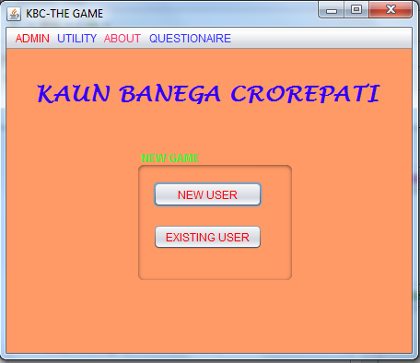

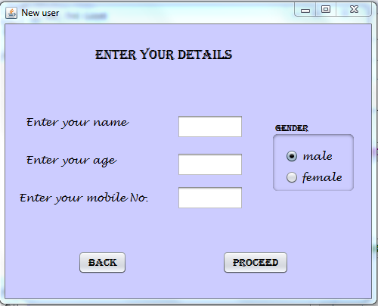

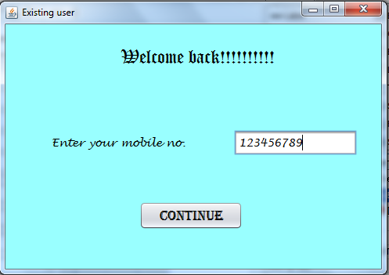

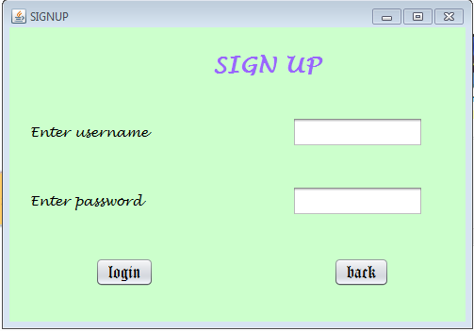

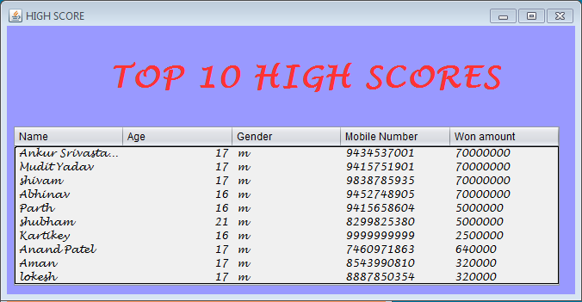

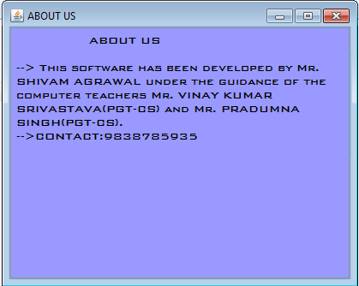

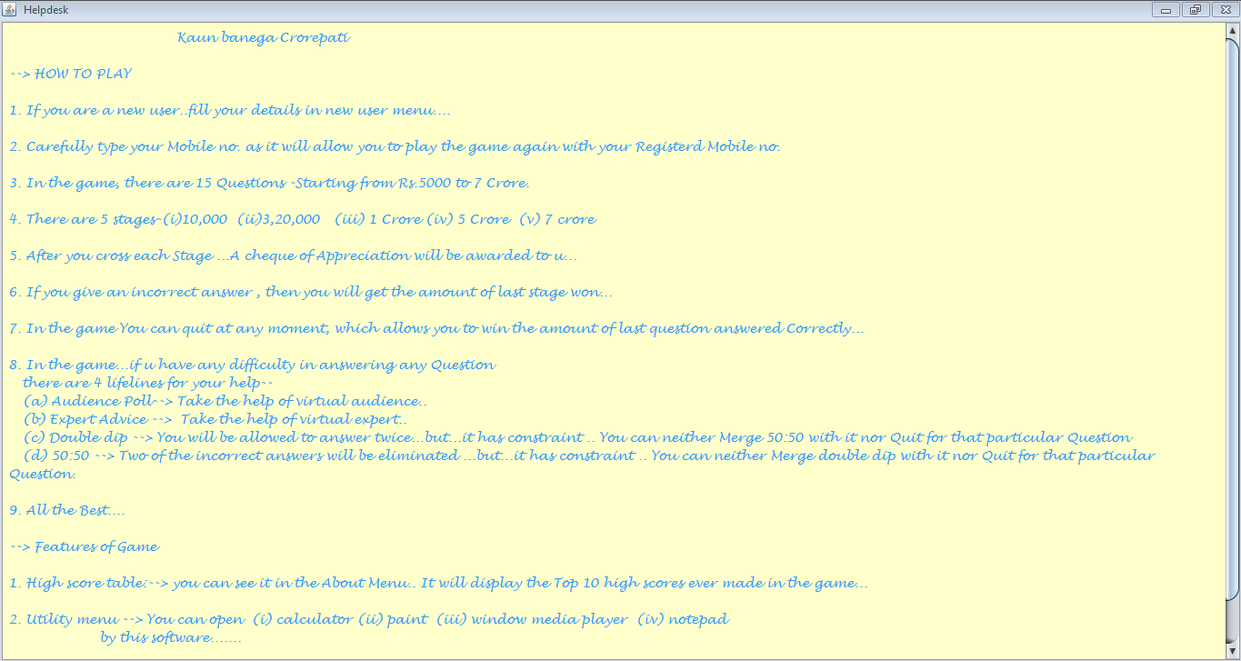

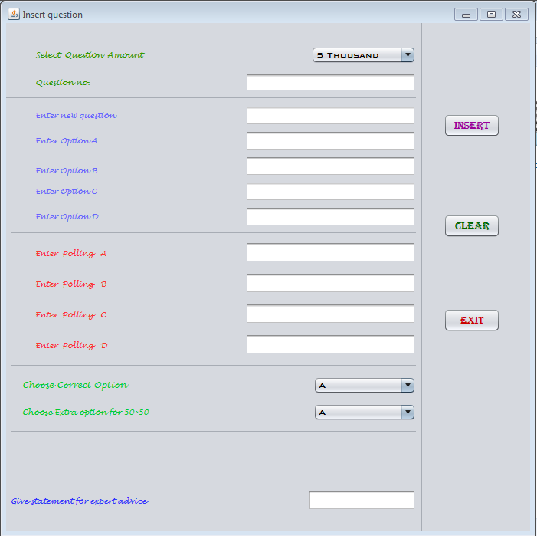

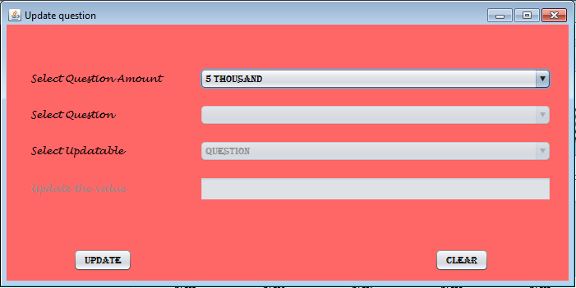

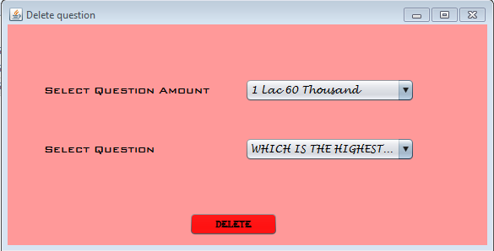

Gameplay

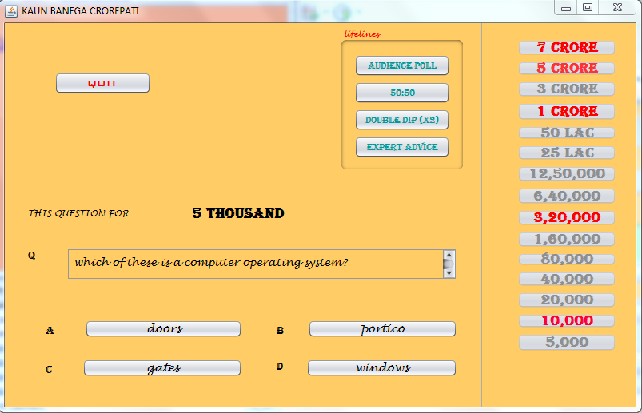

Answering

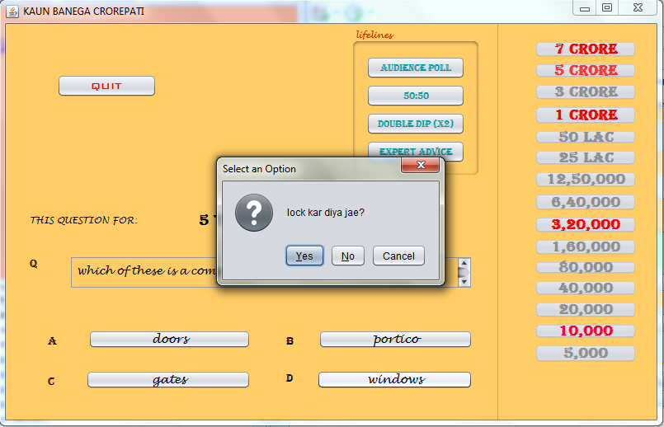

Correct Answer

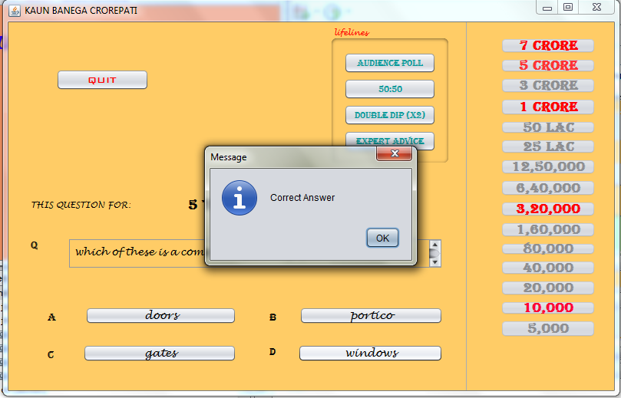

Wrong Answer

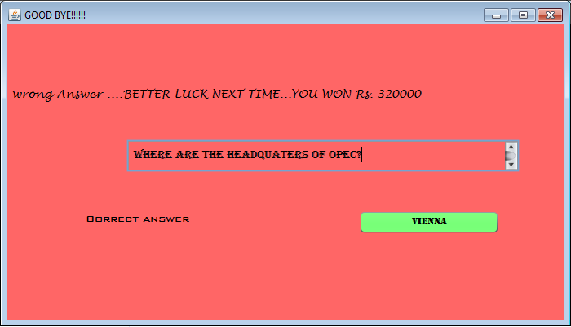

Quitting
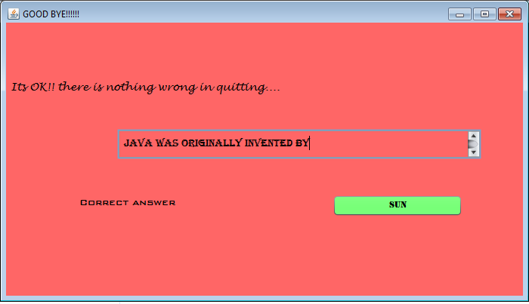

Taking Audience Poll

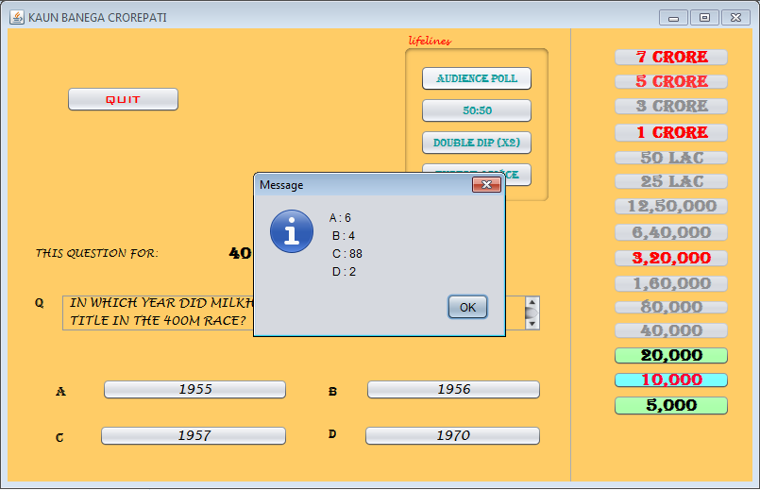

Taking 50:50

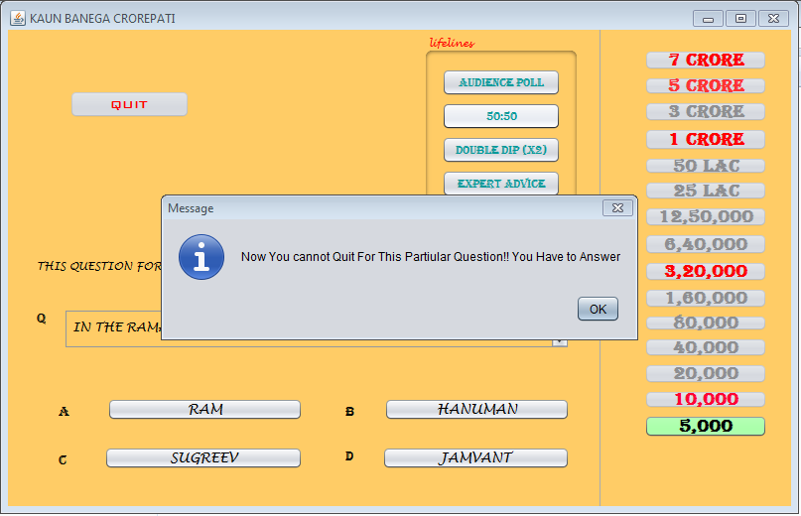

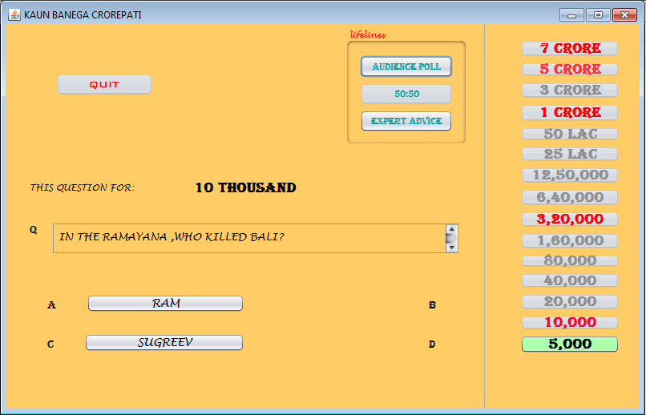

Taking Double Dip

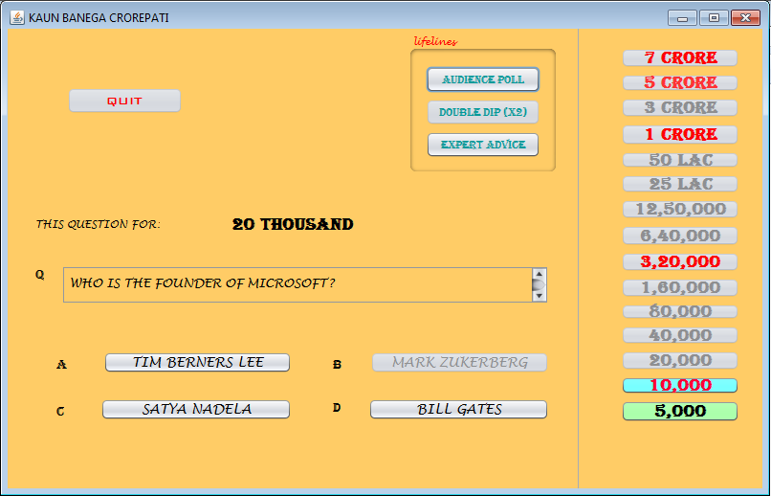

Crossing A Stage

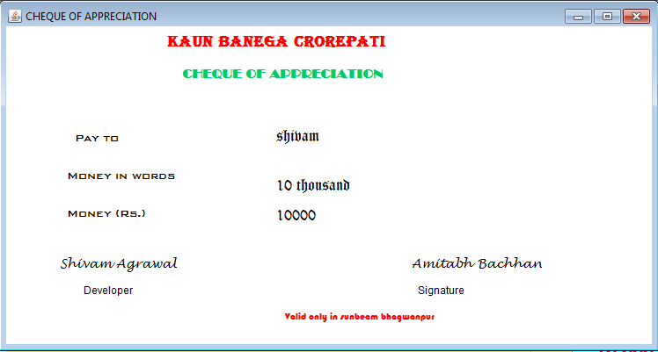

Winning The Entire Game

